Tela de exibição individual de carro

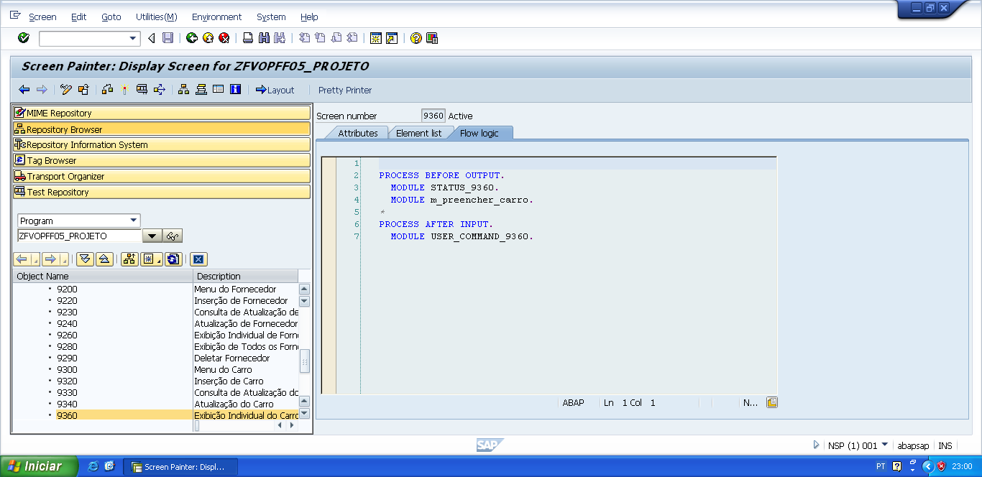

PROCESS BEFORE OUTPUT.  
  MODULE STATUS_9360.  
   MODULE m_preencher_carro.

*&---------------------------------------------------------------------*  
*&      Module  STATUS_9360  OUTPUT  
*&---------------------------------------------------------------------*  
*       text  
*----------------------------------------------------------------------*  
MODULE status_9360 OUTPUT.  
  SET PF-STATUS 'STATUS9360'.  
  SET TITLEBAR 'TITULO9360'.  
  
ENDMODULE.                 " STATUS_9360  OUTPUT

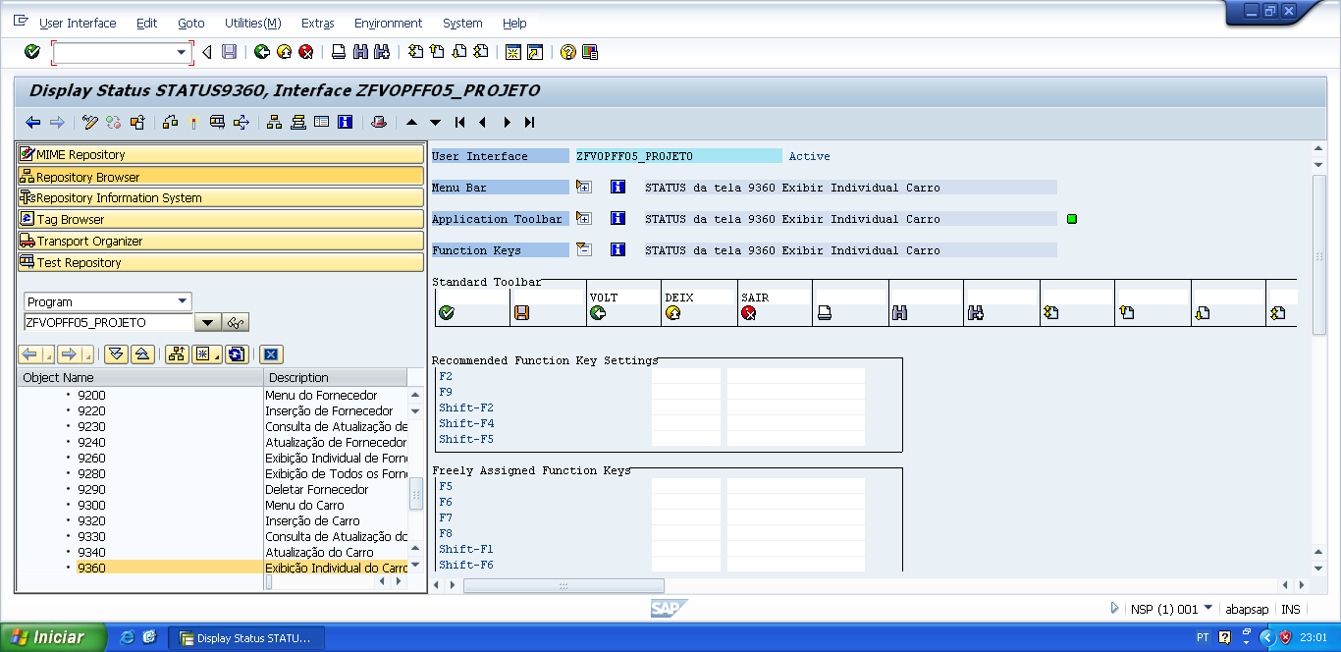

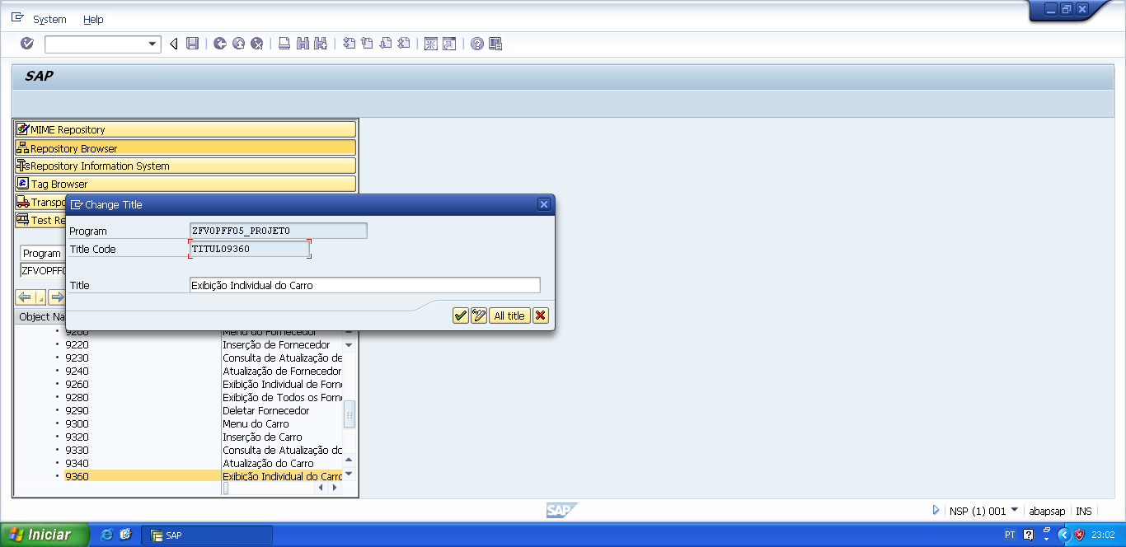

*&---------------------------------------------------------------------*  
*&      Module  M_PREENCHER_CARRO  OUTPUT  
*&---------------------------------------------------------------------*  
*       text  
*----------------------------------------------------------------------*  
module M_PREENCHER_CARRO output.  
  
PERFORM f_preencher_carro.  
  
endmodule.                 " M_PREENCHER_CARRO  OUTPUT

*&---------------------------------------------------------------------*  
*&      Form  F_PREENCHER_CARRO  
*&---------------------------------------------------------------------*  
*       text  
*----------------------------------------------------------------------*  
*  -->  p1        text  
*  <--  p2        text  
*----------------------------------------------------------------------*  
FORM f_preencher_carro .  
  
  v_chassi_car = wa_zfvtpff05_carro-chassi_carro.  
  v_modelo_car = wa_zfvtpff05_carro-modelo_carro.  
  v_ano_car    = wa_zfvtpff05_carro-ano_carro.  
  v_cor_car    = wa_zfvtpff05_carro-cor_carro.  
  v_cnpj_forn  = wa_zfvtpff05_carro-cnpj_fornecedor.  
  v_cpf_cli    = wa_zfvtpff05_carro-cpf_cliente.  
  
ENDFORM.                    " F_PREENCHER_CARRO

PROCESS AFTER INPUT.  
   MODULE USER_COMMAND_9360.

*&---------------------------------------------------------------------*  
*&      Module  USER_COMMAND_9360  INPUT  
*&---------------------------------------------------------------------*  
*       text  
*----------------------------------------------------------------------*  
MODULE user_command_9360 INPUT.  
  
  v_okcode = sy-ucomm.  
  
  CASE v_okcode.  
    WHEN 'VOLT'.  
      PERFORM f_voltar.  
    WHEN 'DEIX'.  
      PERFORM f_deixar.  
    WHEN 'SAIR'.  
      PERFORM f_sair.  
  ENDCASE.  
  
  CLEAR v_okcode.  
ENDMODULE.                 " USER_COMMAND_9360  INPUT

*&---------------------------------------------------------------------*  
*&      Form  F_VOLTAR  
*&---------------------------------------------------------------------*  
* FORM de voltar, serve para voltar automaticamente para a tela  
*anterior da tela atual.  
*----------------------------------------------------------------------*  
*  -->  p1        text  
*  <--  p2        text  
*----------------------------------------------------------------------*  
FORM f_voltar.  
  
*Volte para á tela 9000 (Tela Principal)  
*ou  
**CALL SCREEN '9000'.**  
  PERFORM f_limpar_variaveis.  
  SET SCREEN 0.  
  LEAVE SCREEN.  
  
  
ENDFORM.                    " F_VOLTAR  
  
*&---------------------------------------------------------------------*  
*&      Form  F_DEIXAR  
*&---------------------------------------------------------------------*  
*       text  
*----------------------------------------------------------------------*  
*  -->  p1        text  
*  <--  p2        text  
*----------------------------------------------------------------------*  
FORM f_deixar .  
  
  LEAVE LIST-PROCESSING.  
  
ENDFORM.                    " F_DEIXAR  
  
*&---------------------------------------------------------------------*  
*&      Form  F_SAIR  
*&---------------------------------------------------------------------*  
*       text  
*----------------------------------------------------------------------*  
*  -->  p1        text  
*  <--  p2        text  
*----------------------------------------------------------------------*  
FORM f_sair.  
  
  LEAVE LIST-PROCESSING.  
  
ENDFORM.                    " F_SAIR